 | Data Briefing 2013  Child Poverty Update  October 2013 | 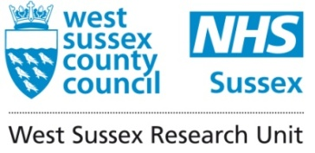
RECAP
The Child Poverty Act 2010 uses four indicators to define child poverty:
relative low income – whether children live in households whose income is 60% or below the national median for the financial year, after adjusting for household size. The national target is less than 10% by 2020 (this is the only target indicator available at county level).
combined low income and material deprivation – a combination measure of children in low income households and found to be materially deprived. For example, whether a child has somewhere outside to play, can swim once a month, can go on school trip once a term. The national target is less than 5% by 2020.
absolute low income – which measures median income compared to fixed baseline year (base year for the Act refers to April 2010). The national target is less than 5% by 2020.
persistent low income – low income persisting for three out of the last four years. The national target is to be finalised once data are available.

Data for the last three national indicators are not available below national level so the measure used for analysis within West Sussex is relative low income.
Child poverty figures, relating to August 2011, were released by HM Revenue and Customs (HMRC) in September 2013. Data are available at county, local authority, ward and neighbourhood level (lower super output area). Tables, including previous years’ data, are available on the West Sussex JSNA website (http://jsna.westsussex.gov.uk).

Headline Figures

- In 2011, 13.0% of all children, and 13.5% of children under 16 years old, were in relative poverty in West Sussex. The percentage of children in poverty fell again between 2010 and 2011, this was in line with national and regional change. See Tables 1 and 2 overleaf

- In 2011, as in 2010, Crawley had the highest rate of child poverty in the county (18.4%), Mid Sussex the lowest (8.1%). All local authority areas had lower rates of child poverty in 2011 than 2010.

- Ham ward in Arun remains the ward with the highest child poverty rate with 33.1%, with one neighbourhood with a rate of 43.4%. This is very close to the highest rate in the country (46.1%).

- As the indicator is a relative measure, a fall in the rate of child poverty reflects a fall in national median income from £440 to £427, this has acted to lower the relative poverty line, so fewer children are said to be in poverty. It is likely that the fall is again due to the fall in incomes in the lower end of the distribution being less than the fall in the middle of the distribution. Also the fall in the number of households with no one in work and an increase in families with two working parents will have contributed. In the UK in 2011-12 real incomes fell by similar amounts across the income distribution – by 2.5% at the 10th percentile, 2.8% at the median and 2.6% at the 90th percentile. National measures of absolute child poverty increased by approximately 2 percentage points in 2011-12.

Table 1: Number and Percentage of Children in Relative Poverty 2007-2011

 | ALL CHILDREN
 | 2007 |  | 2008 |  | 2009 |  | 2010 |  | 2011
 | Number | % | Number | % | Number | % | Number | % | Number | %
Adur | 2,100 | 17.3% | 2,030 | 16.8% | 2,215 | 18.2% | 2,070 | 16.9% | 2,045 | 16.5%
Arun | 4,555 | 16.4% | 4,345 | 15.7% | 4,625 | 16.5% | 4,445 | 15.8% | 4,440 | 15.8%
Chichester | 2,595 | 12.0% | 2,625 | 12.1% | 2,775 | 12.6% | 2,695 | 12.2% | 2,570 | 11.7%
Crawley | 4,145 | 18.1% | 4,190 | 17.9% | 4,585 | 19.0% | 4,695 | 18.9% | 4,675 | 18.4%
Horsham | 2,405 | 8.8% | 2,345 | 8.6% | 2,595 | 9.4% | 2,505 | 9.1% | 2,395 | 8.7%
Mid Sussex | 2,390 | 8.3% | 2,290 | 7.9% | 2,535 | 8.6% | 2,420 | 8.2% | 2,425 | 8.1%
Worthing | 3,130 | 15.1% | 2,985 | 14.3% | 3,315 | 15.7% | 3,270 | 15.4% | 3,155 | 14.7%
West Sussex | 21,320 | 13.2% | 20,815 | 12.8% | 22,640 | 13.8% | 22,100 | 13.3% | 21,695 | 13.0%
South East | 264,730 | 14.9% | 260,920 | 14.5% | 280,755 | 15.4% | 275,935 | 15.0% | 270,945 | 14.6%
ENGLAND | 2,397,645 | 21.6% | 2,341,975 | 20.9% | 2,429,305 | 21.3% | 2,367,335 | 20.6% | 2,319,450 | 20.1%
Source : HMRC – Before Housing Costs

Table 2: Number and Percentage of Children (Under 16 years) in Relative Poverty 2007-2011

 | Children Under 16 Years
 | 2007 |  | 2008 |  | 2009 |  | 2010 |  | 2011
 | Number | % | Number | % | Number | % | Number | % | Number | %
Adur | 1,900 | 18.2% | 1,820 | 17.5% | 1,960 | 18.7% | 1,795 | 17.2% | 1,785 | 17.0%
Arun | 4,085 | 17.3% | 3,835 | 16.3% | 4,050 | 17.1% | 3,845 | 16.2% | 3,880 | 16.3%
Chichester | 2,305 | 12.6% | 2,330 | 12.7% | 2,425 | 13.1% | 2,340 | 12.6% | 2,230 | 12.0%
Crawley | 3,775 | 19.0% | 3,775 | 18.7% | 4,090 | 19.5% | 4,165 | 19.5% | 4,165 | 19.0%
Horsham | 2,155 | 9.2% | 2,065 | 8.9% | 2,275 | 9.8% | 2,195 | 9.5% | 2,095 | 9.1%
Mid Sussex | 2,145 | 8.7% | 2,025 | 8.2% | 2,235 | 8.9% | 2,140 | 8.5% | 2,130 | 8.4%
Worthing | 2,775 | 15.7% | 2,635 | 14.8% | 2,915 | 16.1% | 2,865 | 15.7% | 2,790 | 15.2%
West Sussex | 19,140 | 13.9% | 18,490 | 13.4% | 19,950 | 14.3% | 19,345 | 13.8% | 19,070 | 13.5%
South East | 238,745 | 15.6% | 233,325 | 15.2% | 249,690 | 16.0% | 243,950 | 15.5% | 239,725 | 15.1%
ENGLAND | 2,141,690 | 22.4% | 2,068,970 | 21.6% | 2,131,350 | 21.9% | 2,066,320 | 21.1% | 2,026,465 | 20.6%
Source : HMRC
Figure 1
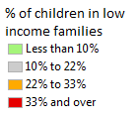
% of Children in Poverty 2011 – Neighbourhood Level
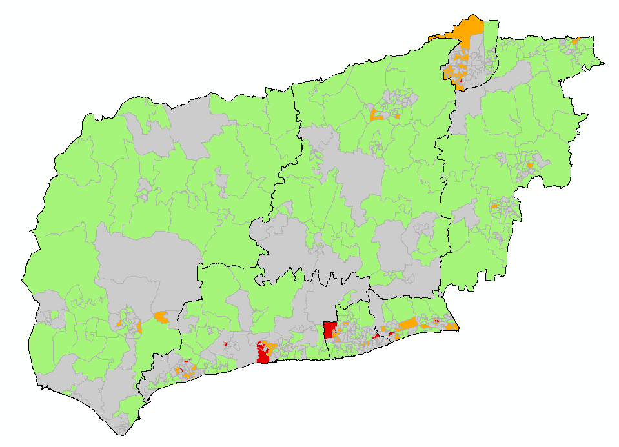
Neighbourhoods with the highest child poverty
LSOA | Ward | Local Authority Area | % of children in poverty
E01031429 | Ham | Arun | 43.4%
E01031779 | Broadwater | Worthing | 39.0%
E01031450 | Pevensey | Arun | 38.5%
E01031558 | Broadfield South | Crawley | 38.2%
E01031819 | Northbrook | Worthing | 38%
E01031427 | Ham | Arun | 38.0%
E01031371 | Southlands | Adur | 34.6%
E01031404 | Bersted | Arun | 34.4%
E01031473 | Yapton | Arun | 33.7%
E01031454 | River | Arun | 33.6%
E01031341 | Churchill | Adur | 33.1%
E01031830 | Salvington | Worthing | 32%

Child Poverty Rates 2009 and 2010
- Change in Median Incomes

The national monthly median income fell from £440, in 2010, to £427 in 2011. Figure 2 shows the values for households with children, for “couple households” homes with two children aged between 5 and 14 median household fell by £19 from £673 to £654. This continued the fall in median income from last year which had not happened in fifteen years.

Although lower quartile incomes also fell, the fall was not proportionately as great, therefore fewer households were 60% or below the median level. This means the child poverty rate was also lower.

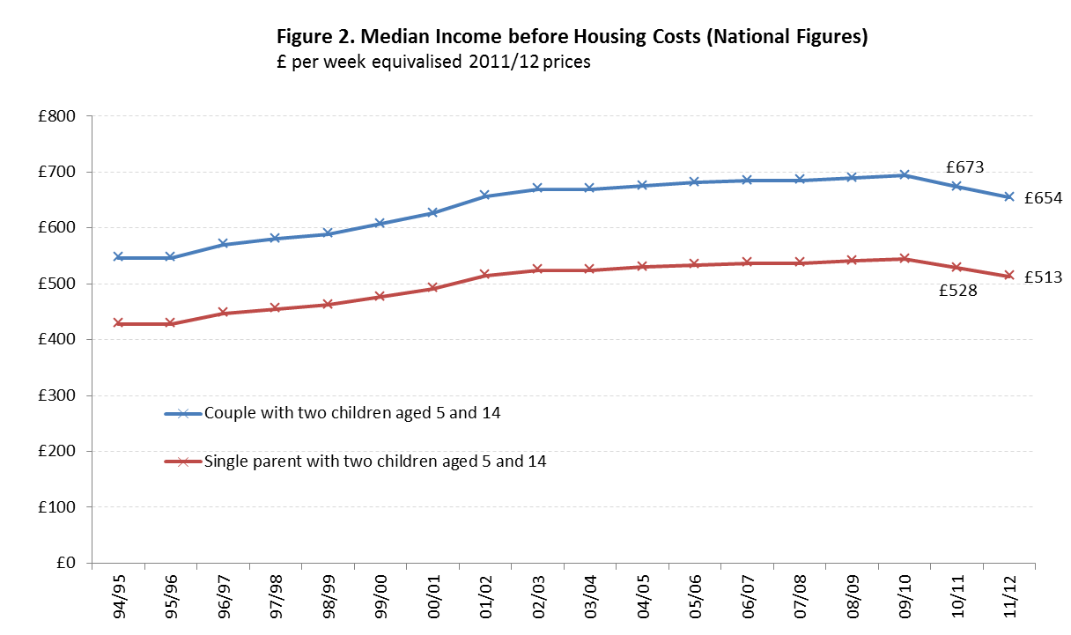

Source: DWP (HBAI report)

Jacqueline Clay
West Sussex Public Health Research Unit
jacqueline.clay@westsussex.gov.uk
07595 964241

Jonathan Cribb, Andrew Hood, Robert Joyce and David Phillips. Living standards, poverty and inequality in the UK: 2013. Institute of Fiscal Studies June 2013 http://www.ifs.org.uk/comms/r81.pdf
Jonathan Cribb, Andrew Hood, Robert Joyce and David Phillips. Living standards, poverty and inequality in the UK: 2013. Institute of Fiscal Studies June 2013 http://www.ifs.org.uk/comms/r81.pdf
Households below average income. Department for Work & Pensions. 2013. https://www.gov.uk/government/organisations/department-for-work-pensions/series/households-below-average-income-hbai--2

