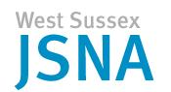 | Data Briefing  National Child Measurement Programme  February 2015 | 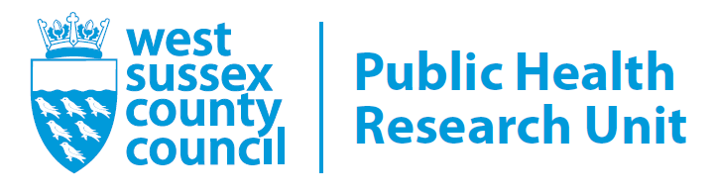
The National Child Measurement Programme (NCMP) for England is an annual record of height and weight measurements of children in state-maintained schools in reception (aged 4-5 years) and year 6 (aged 10-11 years). There are now eight years of reliable data starting in 2006/07. The programme collects data for the child excess weight indicators in the Public Health Outcomes Framework.
The NCMP uses the British 1990 (UK90) growth reference to assign each child a body mass index (BMI) centile whilst taking into account weight, height, age and gender. They are grouped using the following definitions:

underweight: up to the 2nd BMI centile;
healthy weight: between 2nd and 85th BMI centile;
overweight: between 85th and 95th BMI centile;
obese: at or above the 95th BMI centile;
overweight and obese combined: combined data of children measured overweight or obese.

Weight status for each child is also made available to parents, and for this purpose clinical definitions of weight status are used which differ to those presented above. The population thresholds used in this report are lower than the clinical thresholds because the population surveillance function of the NCMP aims to capture both those children with a current weight problem and those at risk of developing a weight problem.

Public Health England (PHE) is responsible for the oversight of the NCMP and the collation and analysis of the data is coordinated by the Health and Social Care Information Centre (HSCIC). This briefing summarises the recent child weight figures that were released by HSCIC in December 2014. Data are available at national, regional, and local authority level and are derived from the postcode of the school.

Tables include prevalence rates and the number of children measured.
Headline Figures

- In 2013/14, over a fifth of all children (22.5%) in reception and around a third (33.5%) in year 6 were classified as either overweight or obese in England. In West Sussex these figures were lower than national and regional levels, with 21.8% of reception age children (4-5 years old) and 29.1% of Year 6 children (10-11 years old) measured as overweight or obese (table 1, figures 1 and 2).

- The South East has the lowest prevalence of obesity for both reception (8.0%) and year 6 (16.4%) children in England (table 1).

- Participation: It should be noted that reported participation rates of reception age children for West Sussex County Council were below the 85% target (61.2%). This was due to data extraction problems following change in provider information systems during the summer term. The participation rate of year 6 children was above the 85% target at 91.2%.

Table 1: Prevalence rates of underweight, healthy weight, overweight and obese children in England, South East and West Sussex, 2013/14 (derived from the postcode of the school).

 | CHILDREN
 | Underweight |  | Healthy weight |  | Overweight including obese |  | Obese |  | Number of children measured
 | Reception | Year 6 | Reception | Year 6 | Reception | Year 6 | Reception | Year 6 | Reception | Year 6
Adur | * | * | ** | ** | 21.94 | 30.04 | 9.69 | 16.09 | 392 | 516
Arun | * | 1.20 | ** | 66.43 | 24.88 | 32.37 | 10.03 | 18.67 | 1,037 | 1,248
Chichester | 0.73 | * | 77.85 | ** | 21.43 | 29.10 | 8.23 | 15.97 | 826 | 914
Crawley | 1.17 | 1.40 | 75.00 | 64.22 | 23.83 | 34.38 | 9.93 | 19.72 | 856 | 1,146
Horsham | * | 1.79 | ** | 71.45 | 20.44 | 26.76 | 7.58 | 13.26 | 778 | 1,282
Mid Sussex | * | 1.27 | ** | 74.45 | 18.64 | 24.29 | 5.86 | 11.63 | 955 | 1,264
Worthing | * | 0.66 | ** | 69.99 | 21.10 | 29.35 | 8.83 | 17.74 | 692 | 913
West Sussex | 0.6% | 1.2% | 77.6% | 69.5% | 21.8% | 29.3% | 8.5% | 16.0% | 5,536 | 7,283
South East | 0.7% | 1.3% | 78.8% | 68.4% | 20.5% | 30.3% | 8.0% | 16.4% | 86,333 | 79,930
ENGLAND | 0.9% | 1.4% | 76.5% | 65.1% | 22.5% | 33.5% | 9.5% | 19.1% | 587,336 | 514,275
Note. *Values are suppressed for disclosure control due to small count.
** Values are suppressed to avoid disclosure by differencing.
Source: HSCIC – NCMP – England 2013/14 school year

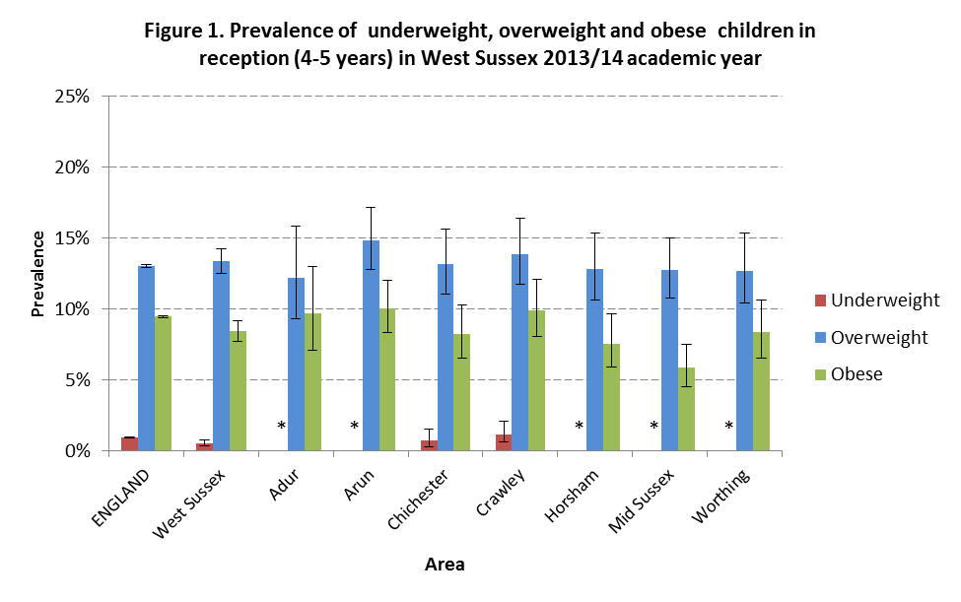

Note. *Values are suppressed for disclosure control due to small count.

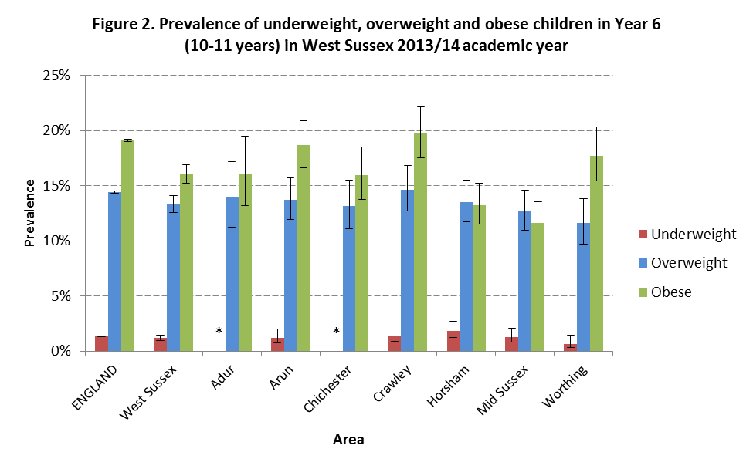
Note. *Values are suppressed for disclosure control due to small count.

- Reception:
  - Since 2006/07, the prevalence of overweight and obese children in West Sussex has been consistently lower than England, and similar to neighbouring East Sussex. However for 2013/14, the prevalence of overweight/obese children in reception (21.8%) is significantly higher than the prevalence (20.5%) amongst the South East region (figure 3).

  - In 2013/14, the percentage of children in West Sussex with a healthy weight (77.6%) was similar to the rest of England (76.5%).
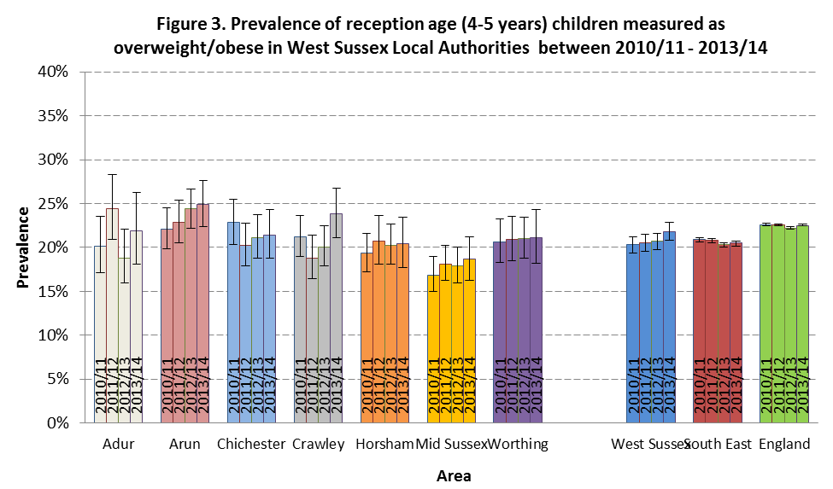
Source: Public Health England ; http://fingertips.phe.org.uk
- Year 6:
  - The prevalence of overweight and obese children in West Sussex has been consistently lower than that reported for England since 2006/07, and this remains the case for the measurements taken in the 2013/14 academic year (figure 4). Prevalence rates over this period for West Sussex and the South East are similar.

  - As with previous years, the percentage of children with a healthy weight is higher in West Sussex than England; in 2013/14 the respective prevalence rates were 70.5% and 65.1%. In recent years, the prevalence of healthy weight year 6 children has been higher in West Sussex than in the South East.

- Comparison of reception with year 6 measurements: In West Sussex, the prevalence rates of children measured as overweight or obese in Year 6 consistently exceeds that of children in reception (table 1). This pattern is also observed regionally and nationally.

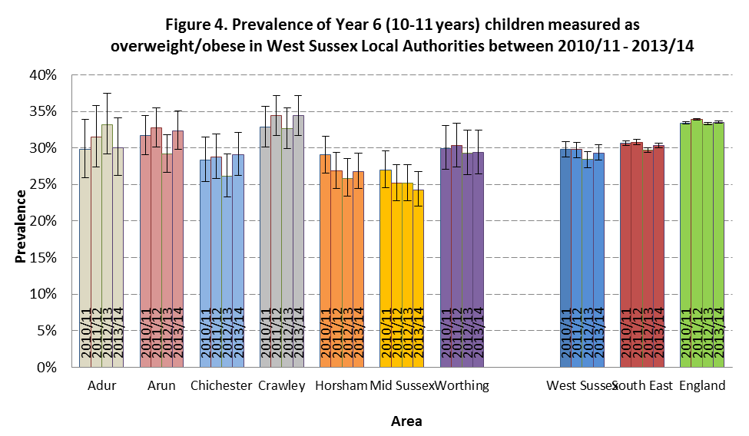 Source : Public Health England ; http://fingertips.phe.org.uk

- Local Authority:
  - Prevalence rates within local authorities of West Sussex are varied (figures 3 and 4). For both school years, no significant change in the percentage of overweight/obese children was seen for any one West Sussex local authority in 2013/14 compared with the previous year.

  - In 2013/14 the prevalence of obese children is significantly lower in Mid Sussex than Arun for reception children and is also lower than Arun and Crawley for year 6 children. For the past 5 years, the prevalence of overweight/obese year 6 children in Mid Sussex has remained significantly lower than in Crawley. The prevalence of obesity is greatest in Arun for reception age children and greatest in Crawley for year 6 children.

- Nationally:
  - Sex: Prevalence of obesity is significantly higher among boys than girls in both school years. In reception, 23.4% of boys and 21.6% of girls were overweight or obese. In year 6, the percentage of boys and girls who were overweight or obese were 35.2% and 31.7% respectively. In both school years, a greater percentage of girls were a healthy weight than boys. 77.7% of girls and 75.4% of boys were a healthy weight in reception. These percentages are lower in year 6, with 66.7% of girls and 63.6% of boys a healthy weight.

  - Deprivation: Prevalence of obesity is strongly related to deprivation. Deprivation is based on the 2010 Index of Multiple Deprivation (IMD) which classifies children into a deprivation decile based on the location of their school (1 = most deprived, 10 = least deprived). In reception, 12% of children who attend a school in the most deprived decile were obese compared to 6.6% of those attending schools in the least deprived decile; these differ significantly from the national average (9.5%). Similarly in year 6, nearly a quarter of children (24.7%) attending a school in the most deprived decile were obese compared to 13.1% of children attending a school in the least deprived decile; again, these percentages differ significantly from the national average (19.1%).

  - Ethnicity: In England, children in the ethnic groups ‘Asian or Asian British’, ‘Black or Black British’, ‘mixed ethnicity’ and ‘any other ethnic group’ were above the national average for both school years; 9.5% of all reception children and 19.1% of year 6 children were classified as obese. Prevalence of obesity in children from “White” (8.8% and 17.6%) and “Chinese” (7.7% and 18.9%) ethnic groups were significantly lower than the national average in both school years.

West Sussex County Council Response and Plans for 2015/16
Although obesity in both age groups is lower than the England prevalence the local figures continue to demonstrate that there is a need for both prevention and weight management within West Sussex’s child and young people’s population. These include:

- Ensure greater reported participation within NCMP. The rate for 2013/14 amongst reception aged children was low. This was due to data extraction problems as a result of IT issues within the provider. Plans are in place to ensure there are no data collection or uploading issues that will impact our participation rate for 2014/15, and we are confident we can achieve the an overall participation rate of 90% of eligible children being measured.

- A children and young people’s healthy weight care pathway has been developed with stakeholders. This covers birth to 19 years. The pathway aims to offer guidance on the identification and assessment of unhealthy weight and weight management intervention. NCMP forms part of the pathway as a way of identifying children with an unhealthy weight and providing an opportunity to proactively engage with parents.

- The pathway has a number of different approaches to prevent and tackle childhood and young person’s obesity based on i) increasing physical activity and reducing sedentary behaviours, ii) improving eating behaviour and iii) adopting a healthy diet, iv) family (or parent/child) focussed programmes and services.

- Maintaining a competent workforce able to deliver high quality preventative and management interventions to West Sussex families. To date 700 staff have attended training across youth offender teams, community health services, Children & Family Centre staff and Early Years practitioners, teachers and school based staff. The training helps professionals identify families at risk and offer a brief intervention and referral to appropriate services. It is planned to train primary care staff throughout 15/16. The model has been highlighted as an example of good practice by Public Health England.

- Weight management services available across West Sussex:
  - HENRY - prevention and weight management intervention provided by health visitors and children and families centre staff to families at risk of obesity;
  - AliveNKicking - a weight management service for children above a healthy weight. This provision is targeted in areas of deprivation and areas with the highest obesity prevalence;
  - Junior Weight Management - local district provision for families in need of support. This service offers additional access to weight management provision to families in need of intense one-to-one support.

- School based healthy lifestyle events across the county which reinforce healthy eating and physical activity messages as well as school bag based advertising and publicity. Both mechanisms offer referral into the WM services.

- Public health specialist staff continuing to support the Healthy Children and Family Centre development and monitor the food and physical activity policy for early years.

- Work with County Catering to ensure school meals and meals in residential settings (e.g. Children Looked After) meet Food Standards but support calorie reduction.

- Local development of the Public Health England drive on sugar reduction – working with local schools and FE college’s on availability of sweetened soft beverages and healthy vending machines to reduce intake of sugar and calories.

The 2010 Index of Multiple Deprivation (IMD) ranks areas from least to most deprived based on seven different dimensions of deprivation (such as income and crime deprivation).

