 | Data Briefing  August 2013 | 

Summary
ONS analysis has considered levels of deprivation in larger English seaside destinations, which may have once thrived on seaside resort tourism. There is a perception that these economies have declined and are enduring high levels of deprivation as a result of people going on holiday abroad rather than in England.
ONS has defined a seaside destination as any seaside settlement to which people travel for the beach and associated activities. There is a degree of subjectivity in this as, for example, Southampton is not included as it is not a settlement people tend to travel to for the beach or associated activities, despite having a publically accessible beach at Weston Shore. Due to each UK country having its own set of indicators for deprivation, only seaside destinations in England have been selected for this article.
The results of the ONS analysis revealed that there were higher levels of deprivation in 2010 than the deprivation measure for England on average. The larger seaside destinations with the highest average deprivation levels were Blackpool, Clacton and Hastings.
The results showed that levels of deprivation in seaside destinations were higher than the levels of deprivation for England on average in 2010. In England overall, 20% of areas were in the most deprived group whereas the level for larger English seaside destination was found to be 26.9%. The deprivation level stayed relatively stable compared with 2007, rising from 26.0%. The six seaside destinations with lower levels of deprivation were Christchurch, Lytham St Annes, Poole, Worthing, Southport and Bognor Regis (with Littlehampton being ranked just one above these 6 at 7). On the other hand the three most deprived seaside destinations of the 57 analyzed in this article were Skegness and Ingoldmells, Blackpool and Clacton.

Figure 1: % of LSOA’s within each location that are in the most deprived quintiles accoring to the IMD
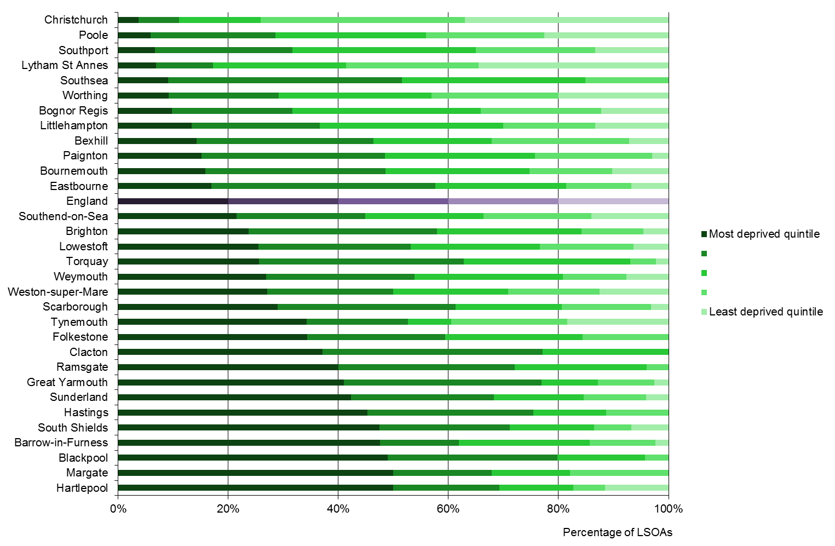

Figure 1 represents the comparison of the percentage of LSOA’s for each town and resort within each ID quintile from 2010. Bognor, Worthing and Littlehampton ranks extremely well, with Littlehampton ranking worst of the 3 West Sussex resorts yet still having only 13.3% of LSOA’s within the lowest quintile, 6.7% lower than the national average. As a whole West Sussex resorts along with Brighton and Bournemouth fared well against other large resorts, although not all southern resorts reached the same standard with nearby Hasting having over 30% more LSOA’s falling into the worst quintile than the West Sussex average.

Ryan Walkley
JSNA Analyst and Research Intern
West Sussex Research Team
Ryan.Walkley@Westsussex.gov.uk

